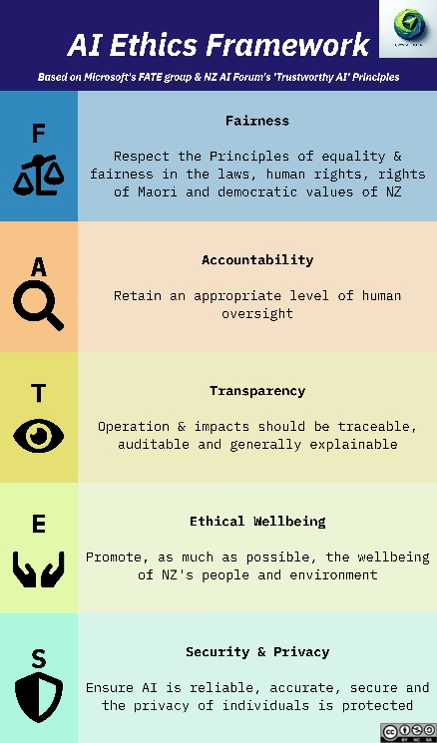
LinkedIn Posts – FATES - Transparency
China is more transparent that the US?!
✨ “That’s not fair!” – A Mini-Series on Ethics in AI - Transparency✨
Like many in AI, I was stunned by NVIDIA’s 15% stock drop overnight. The industry believed America’s tech billionaires, and associated machines political, technical and organisational, had an unshakable lead. I hadn’t truly believed China would surprise us, but here we are.
For me, it’s not the ability to produce a comparable LLM, not even that Deepseek did it cheaper and faster, but that IT’S OPEN SOURCE!
🧑‍⚖️ Today – T for Transparency
In the debate over AI progress by the big companies – Google, Open AI, Microsoft, Anthropic – I’ve always felt Meta’s attempts to be of little consequence; both because they don’t seem to be rated in popularity or in performance, but to be frank, I’ve always thought of opensource (which is their chosen metier and rhetoric) as useful, but not world breaking.
It seems I’m wrong!
And very glad to be. Deepseek has, overnight, brought Open Source to the top of the pile. Proving that transparency isn’t just idealistic - it’s powerful, it’s key to surface biases, ensure fair AI development and create an equal organisation/society. Big tech provided ‘Chain-of-thought’ and ‘reasoning’ models to show transparency, but I wonder if this is a phase, and the public will start to trust ‘enough’, as gauged by the billionaires, and this facility will go away?
However, the purpose of these blog posts is to create a resource you can go back to to ensure Transparency, so here we go:
- Create a ‘questioning channel’ – for user feedback and redress.
- AI Audit – this is becoming a theme.
- Use models which are considered ‘chain of thought’ or ‘reasoning’ models.
- Explainability dashboard – showing reasoning, results, overrides and what-ifs.
- Open source your models or algorithm – we are all victims of algorithms that make ‘no sense’ to us; don’t be one of them.
- Maintain Model Cards (like nutrition labels for AI) documenting architecture and training sources.
- Clearly communicate where and how AI is being used in your business processes.
- Ensure a human-in-the-loop can override AI decisions.
- Governance – clearly articulate where the buck stops; it should always be with a human.
…and I’m going to assume that you’re already making sure you abide by AI regulations and data protection measures. If you’re not doing that then you won’t start from reading this article!
If AI is shaping the future, transparency needs to be non-negotiable. How is your organisation ensuring transparency in AI? Comments below 👇

#EthicalAI #AIForBusiness #AITraining #FATESFramework

